i) Handling missing values in columns.
ii) Removing duplicate rows.

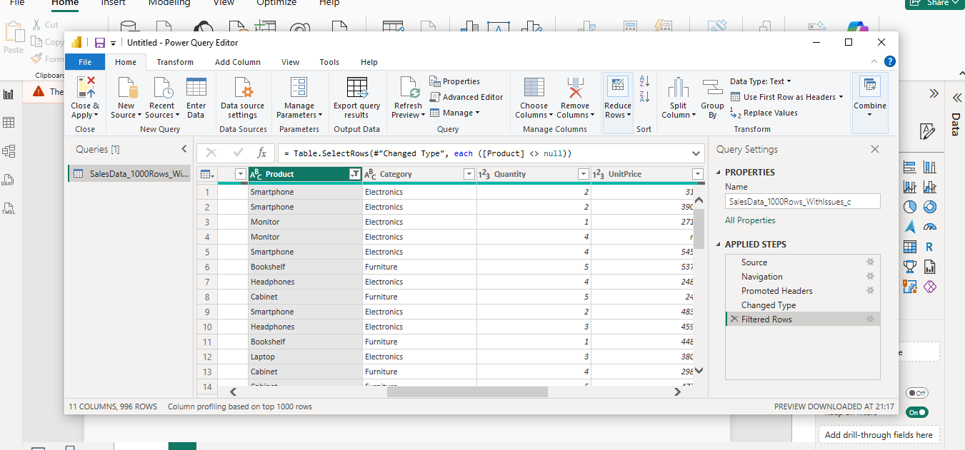
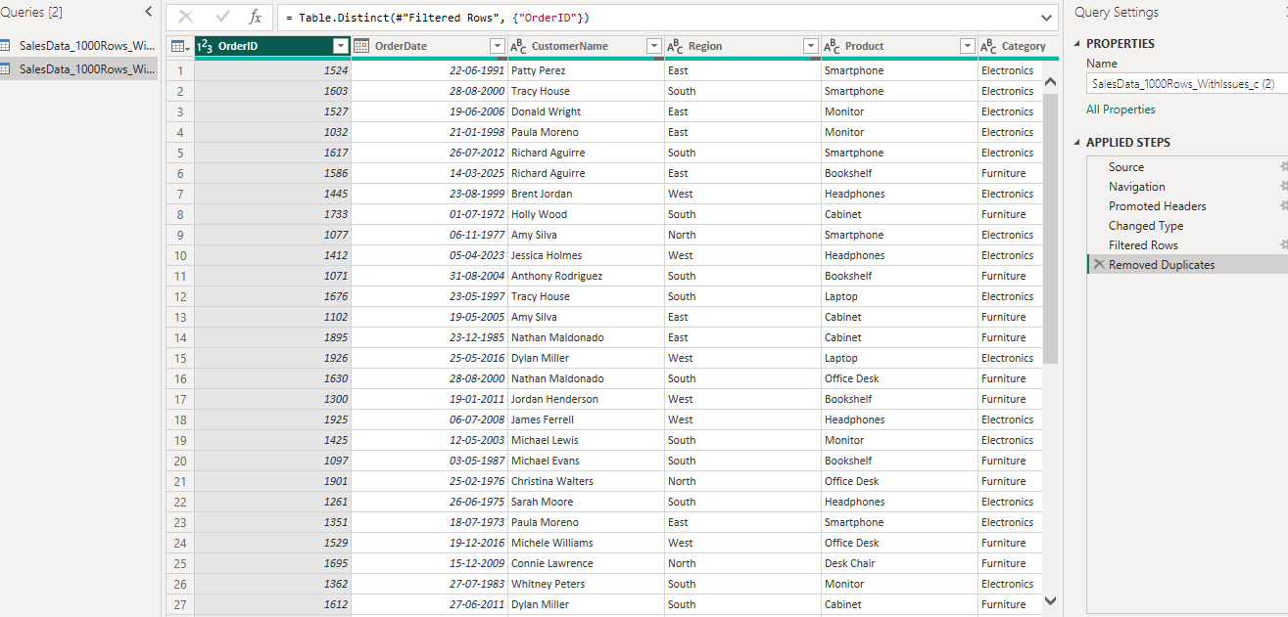
iii) Standardizing the OrderDate column to a consistent date format.
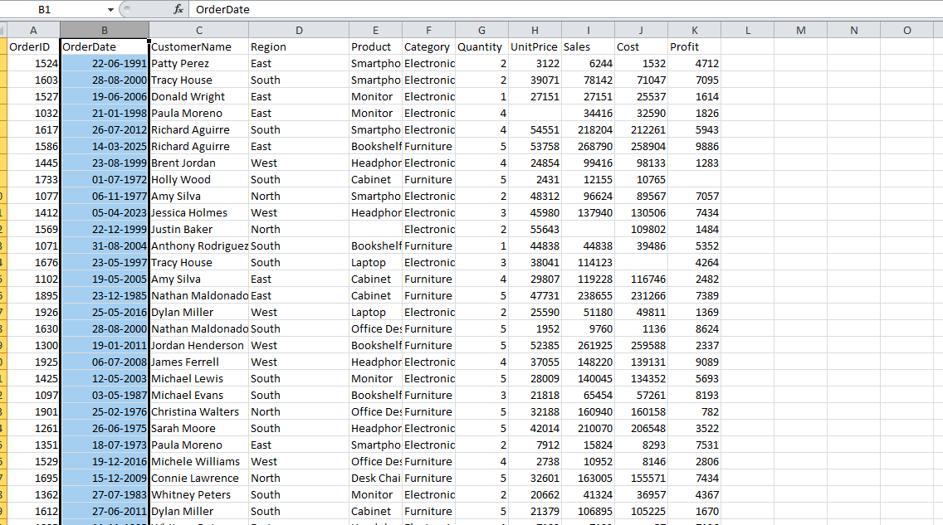
c) Load the cleaned dataset into the Power BI model.
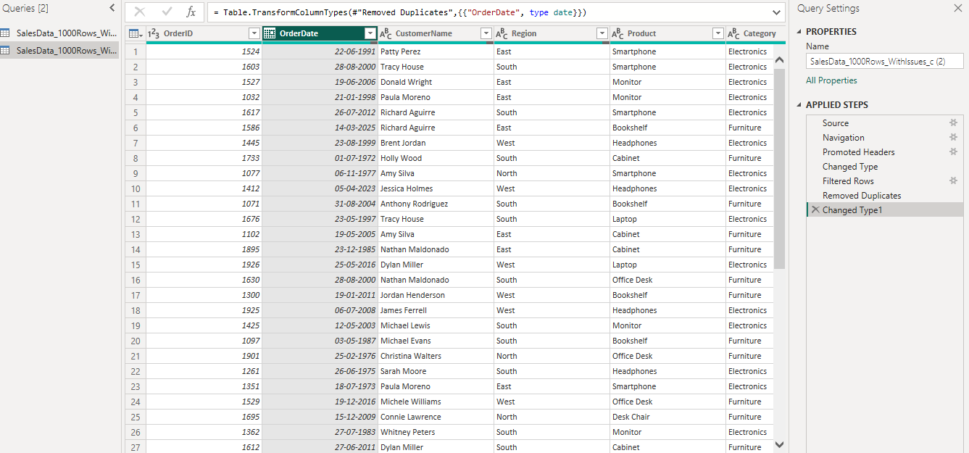

Q2: Visualizations and Insights (5 Marks)
Using the cleaned dataset, create meaningful visual representations to analyze order and profit trends.
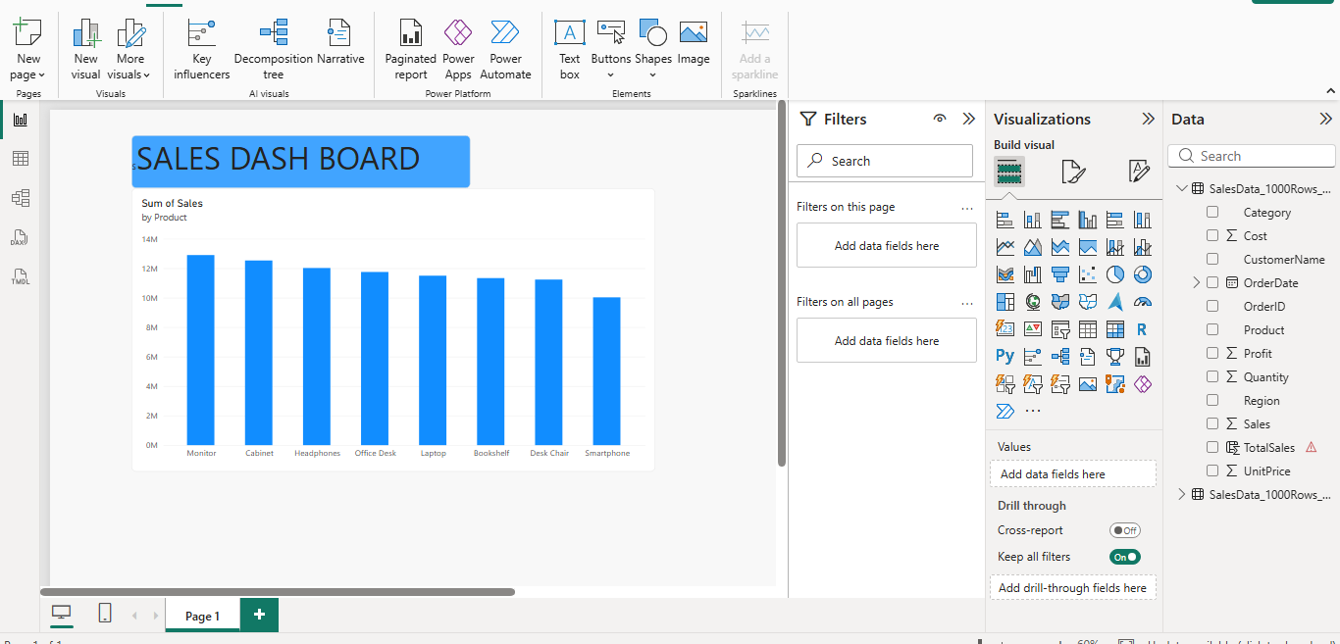

Tasks: a) Create a Pie Chart showing order distribution across different regions.
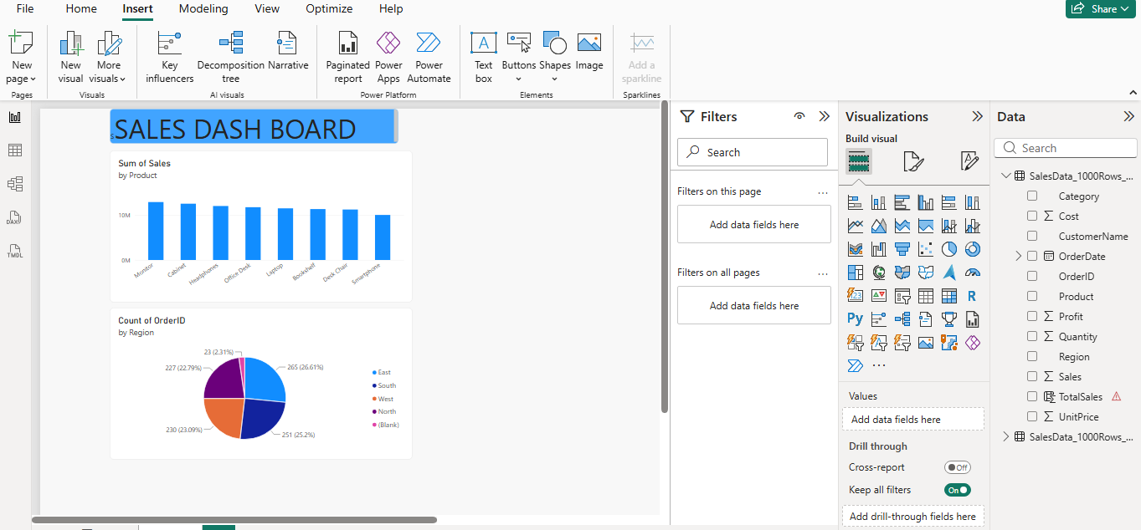
b) Create a Column Chart to display the top 5 trending products based on the number of times each product was ordered
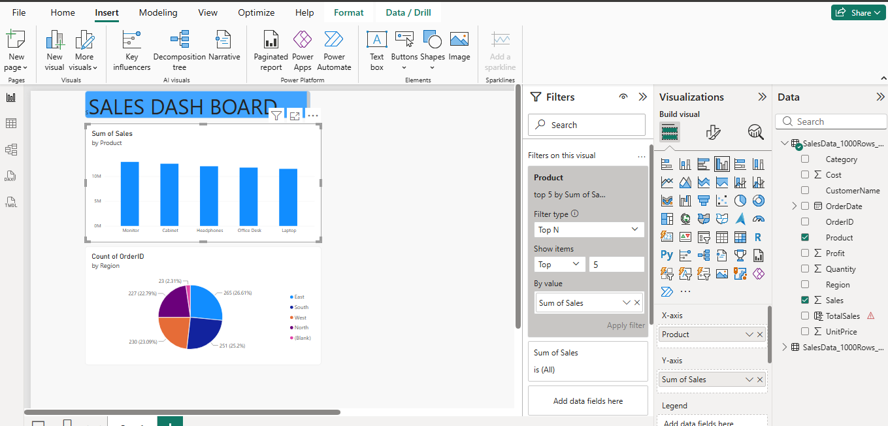.
c) Create a Line Chart to show the profit trend over time.
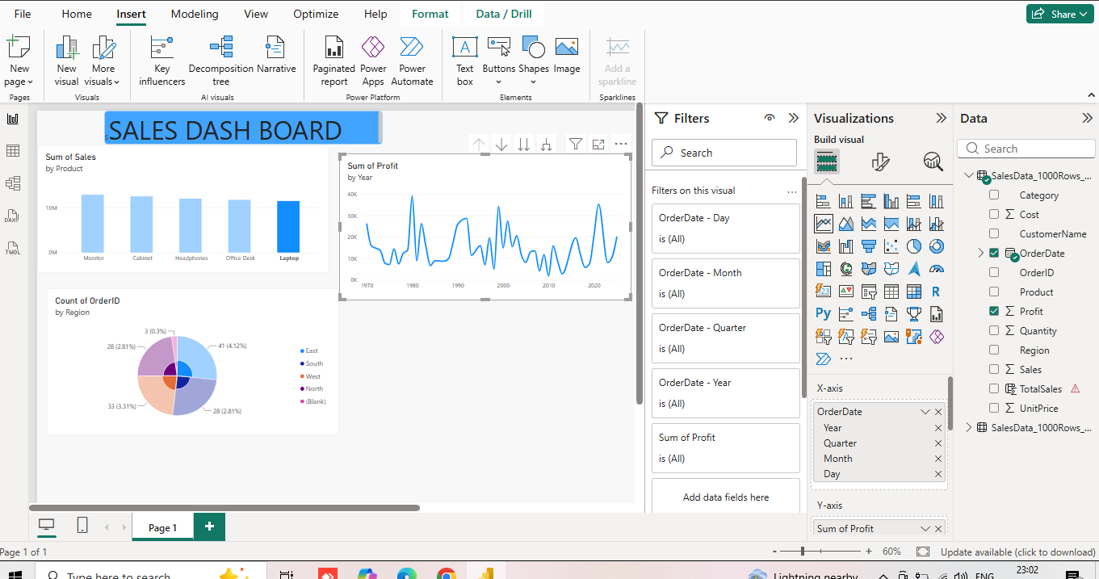

Tasks: a) Create a Calculated Table named EastRegionOrders that filters and displays only the orders from the East region.
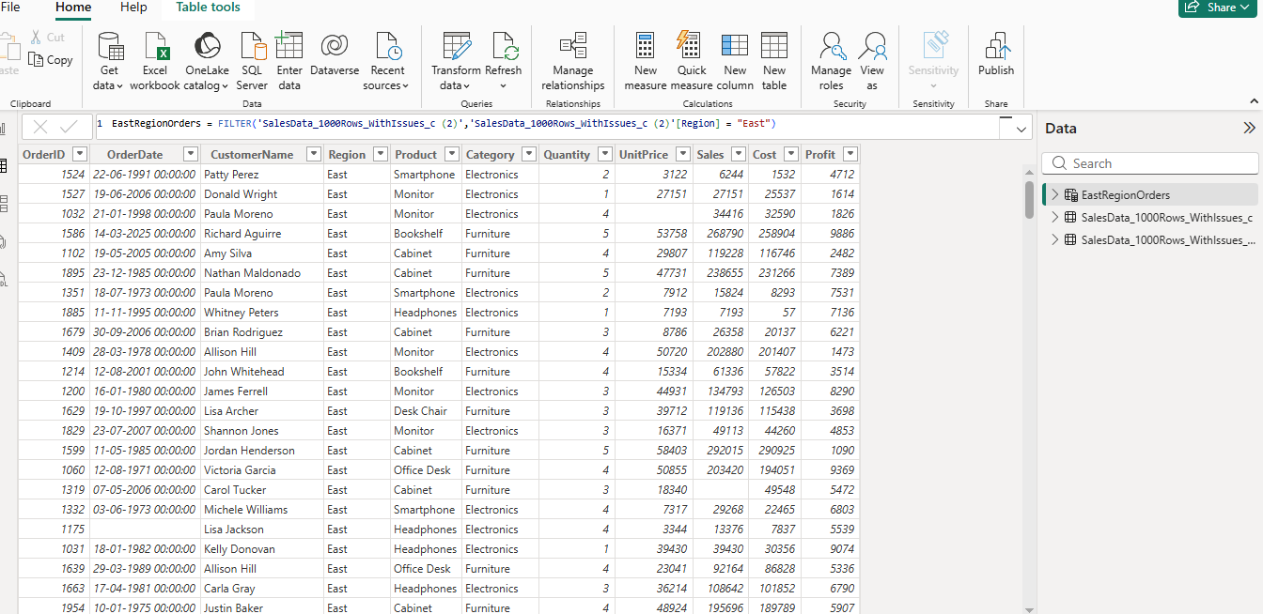
b) Create a Calculated Column to compute the difference between the Profit and Cost columns. Name it ProfitCostDifference.
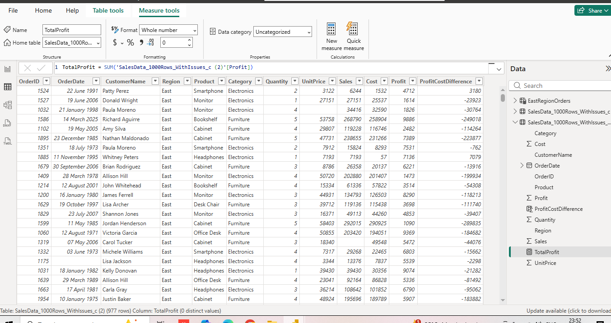
c) Create a Calculated Measure to find the total profit earned. Name it TotalProfit

